Angular and Spring Boot E-commerce App Steps

Format: shift + option + F

Overview

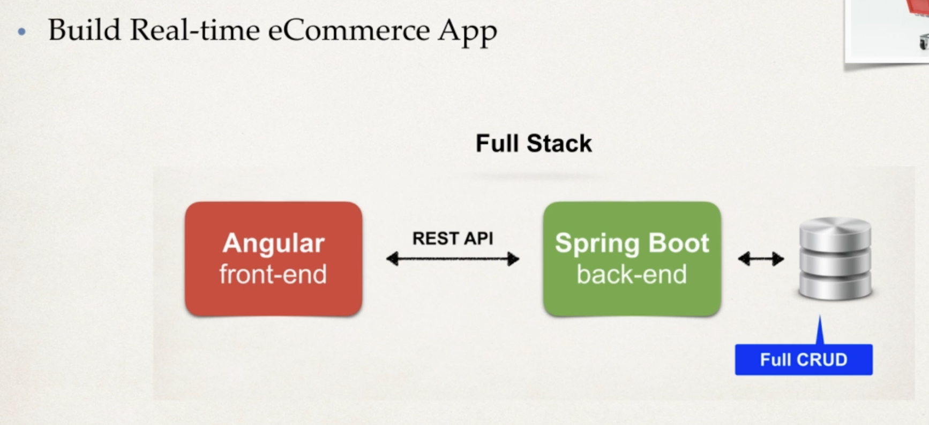

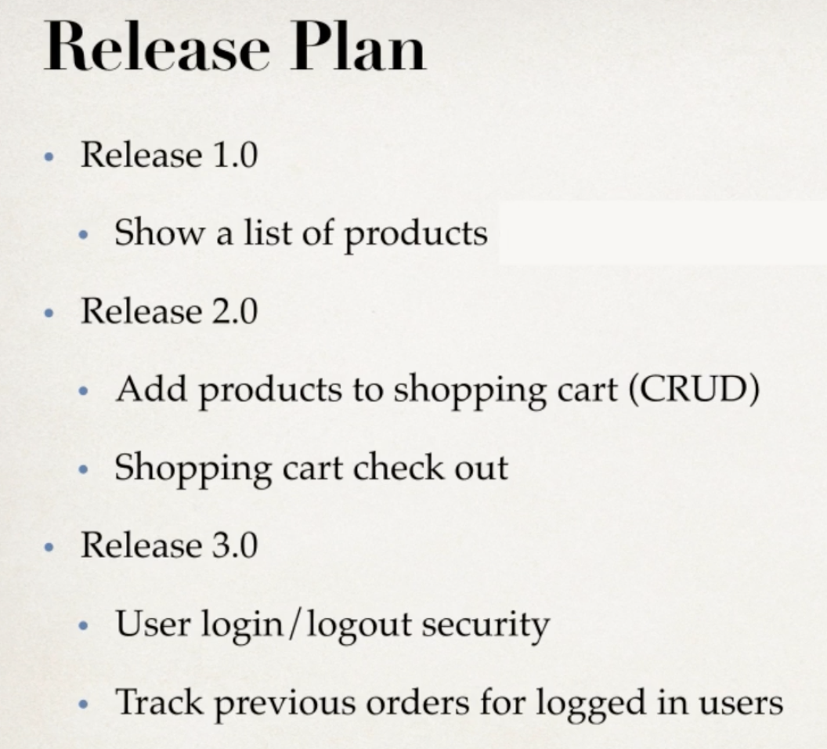

09 SpringBoot Backend

Development Process:

1. Set up the database tables: MySQL
2. Create a SpringBoot starter project (start.spring.io)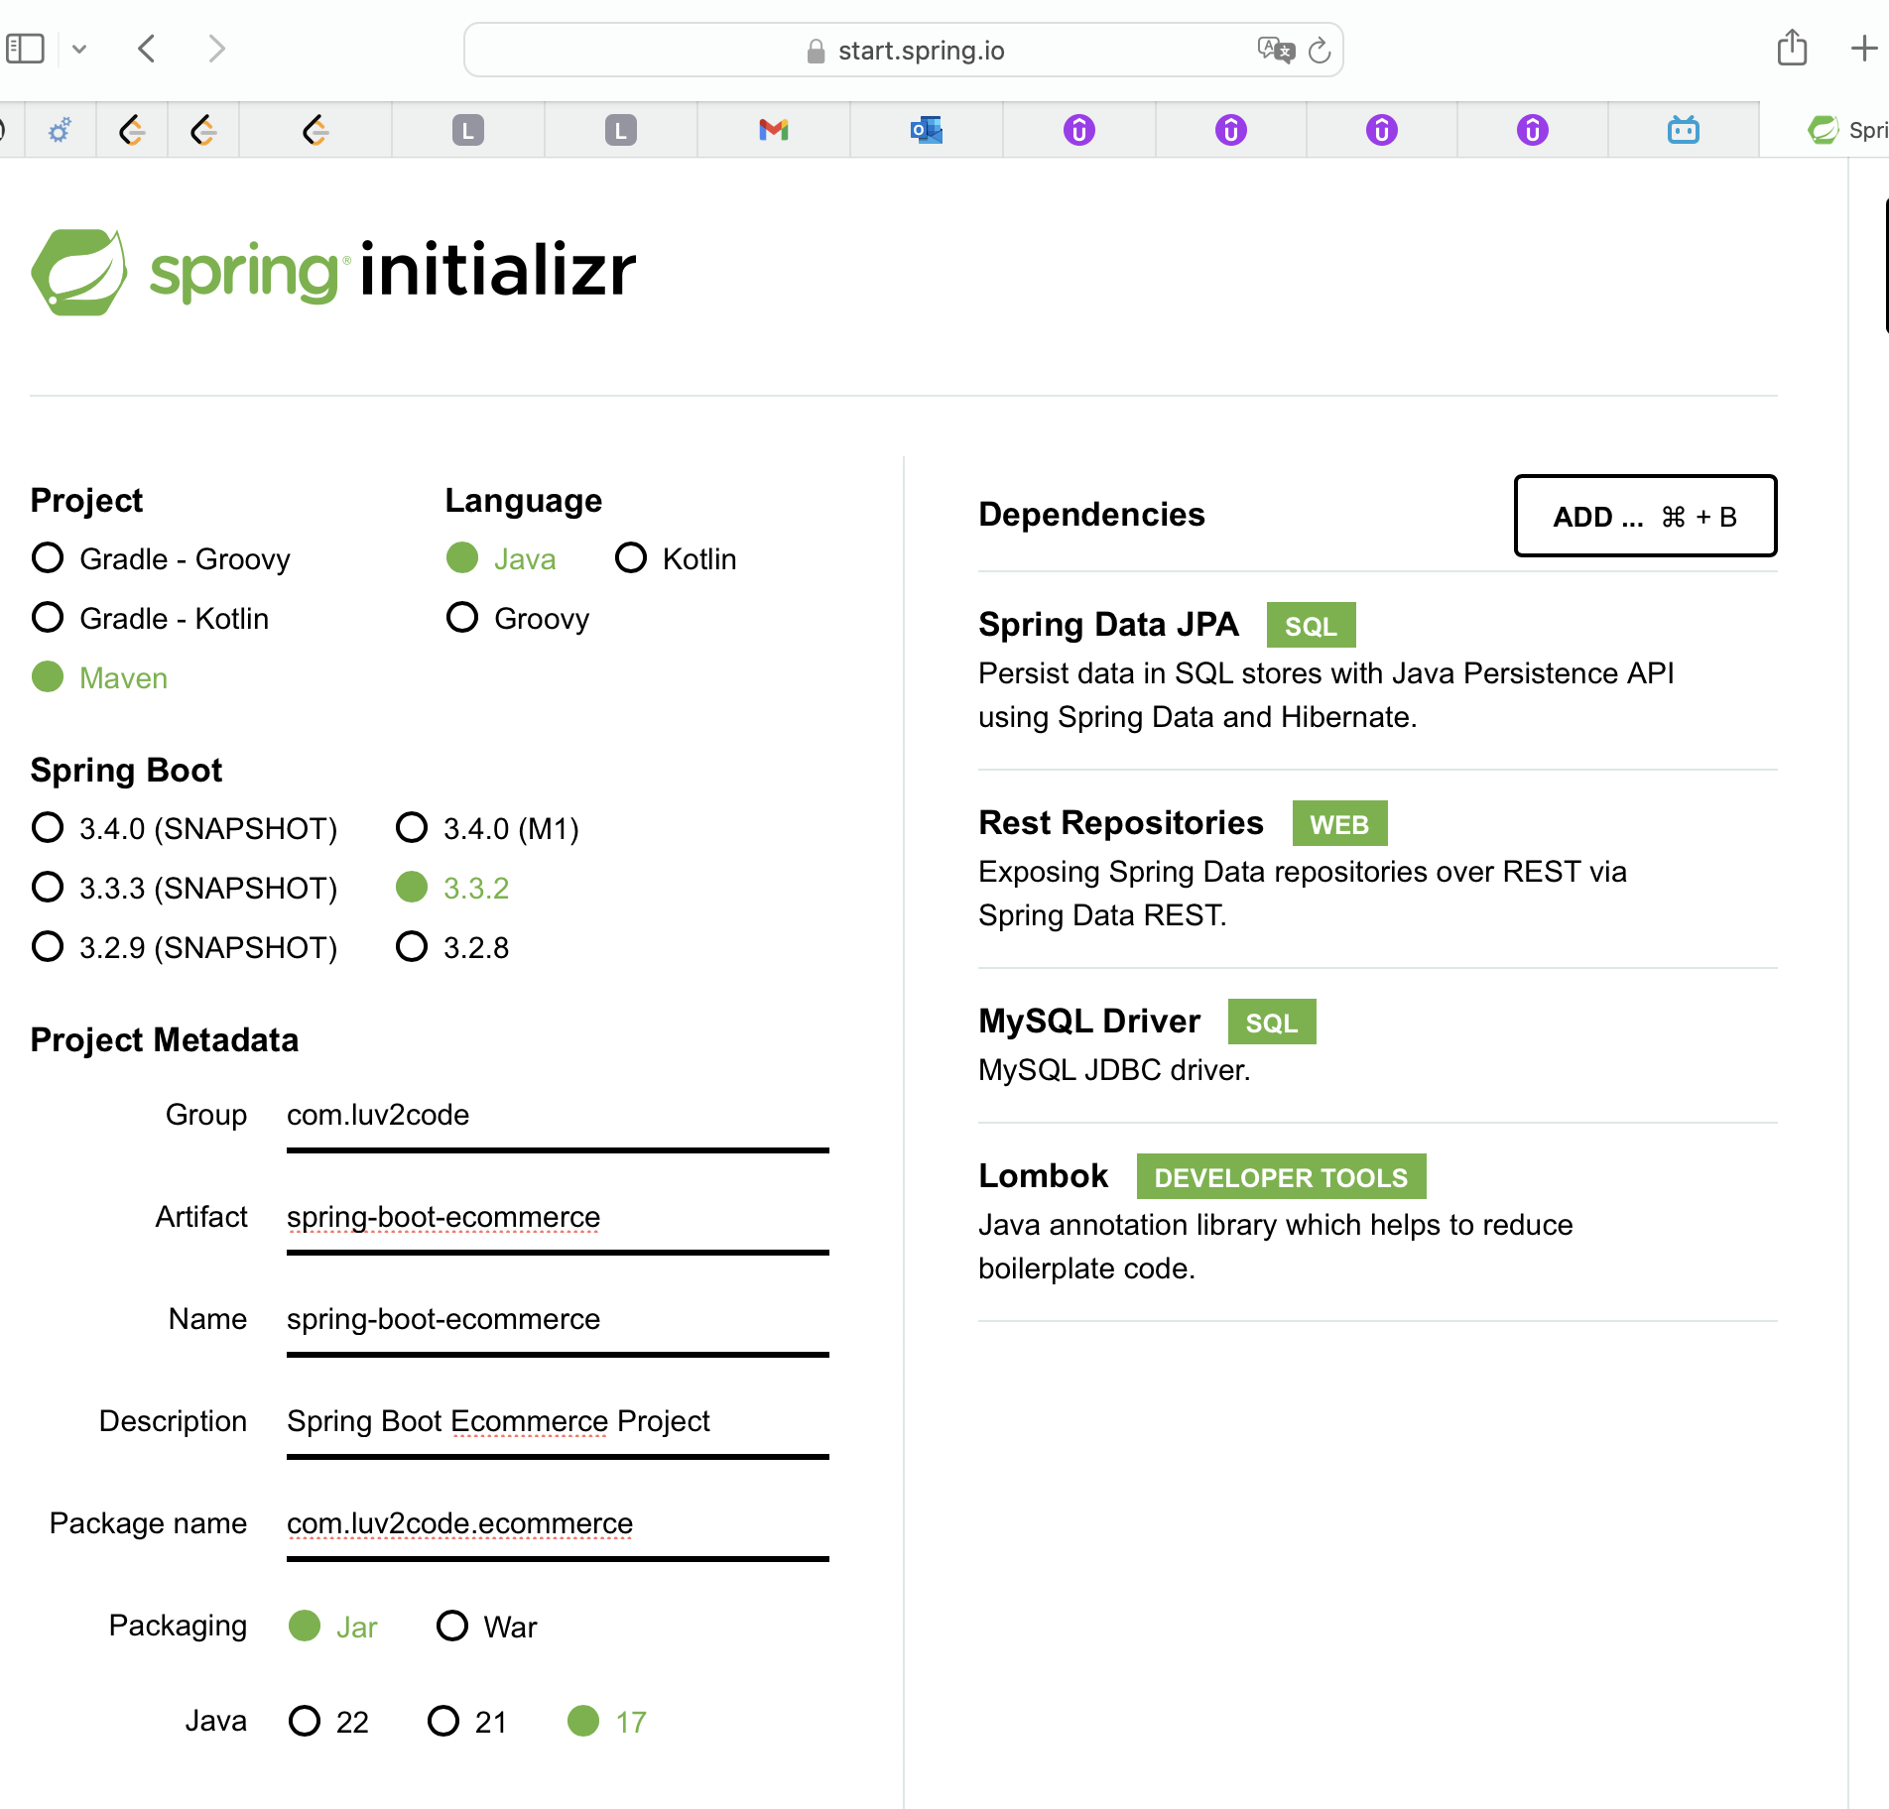
3. Develop the Entities: Product and Product Category
   1. New package: entity -> new java class: Product and ProductCategory
   2. Note: ManyToOne, OneToMany
4. Create REST APIs with Spring Data JPA Repositories and Spring Data REST
   1. New package: dao -> new Interface: ProductRepository and ProductCategoryRepository
5. Make the REST API as READ-ONLY
   1. New package: config -> new java class: MyDataRestConfig
   2. Disable HTTP methods: POST, PUT, DELETE
   3. Test with Postman

10 Augular Frontend

Development process

1. Create Angular project
   1. Terminal; ng new angular-ecommerce -> n for routing, CSS
2. Create Angular component for product-list
   1. Ng generate component components/product-list
3. Develop TypeScript class for Product
   1. Ng generate class common/product
   2. Add constructor
4. Create Angular service to call REST APIs  
   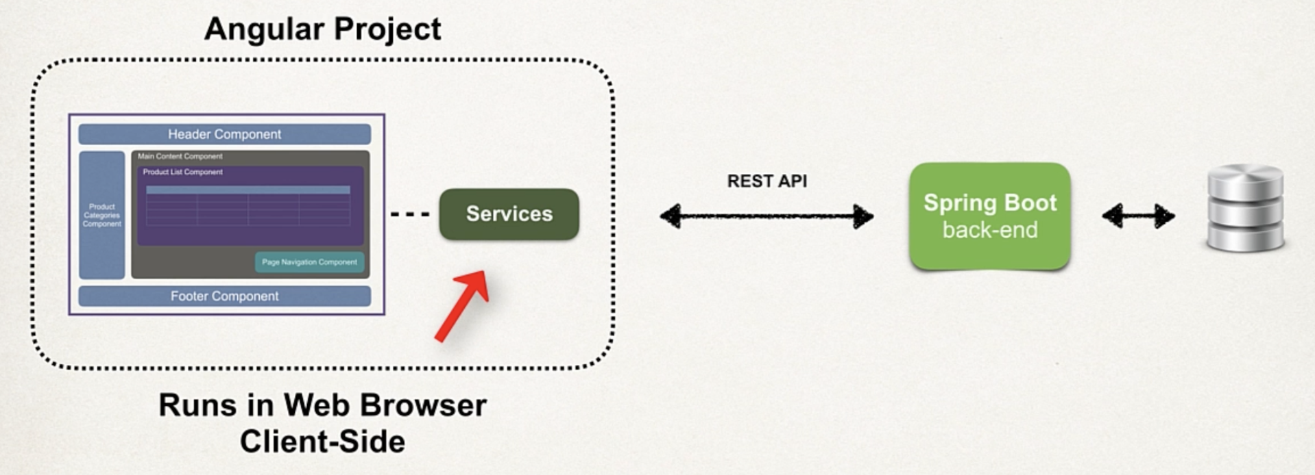
   1. Ng generate service services/product
   2. App.module.ts: add HttpClientModule and ProductService
   3. Product.service.ts: Inject HttpClient; Map the JSON data from SpringData REST to Product array; Unwraps the JSON from Spring Data REST _embedded entry
5. Update Angular component to subscribe to data from Angular service
   1. Product-list.component.ts: Inject ProductService, subscribe, integrating service with angular component
6. Display the data in an HTML page
   1. Product-list.component.html
   2. Display list of products in an HTML table
7. Add CrossOrigin support to Spring Boot app
   1. Specific to JavaScript running on website.  
      Origin = protocol + hostname + port
   2. ProductRepository: add @CrossOrigin
   3. The same for ProductCategoryRepository
8. Add images to assets directory

11 Integrating online shop template

Release 2.0 – Plan

* Online shop template integration
* Search for products by category
* Search for products by text box
* Master / detail view of products
* Pagination
* Add products to shopping cart (CRUD)
* Shopping carts check out

Development Process

1. Download the HTML template starter files
2. Install Bootstrap CSS styles locally using npm
   1. Npm install bootstrap
   2. Npm install fortawesome/fontawesome-free
3. Add local custom CSS styles to Angular src/styles.css file
4. Integrate template files into Angular app
   1. Source -> app -> App.component.html
   2. Copy from home.html
      1. Menu sidebar
      2. Container – Desktop
      3. Footer
5. Add support for icons and logos
   1. copy product-list-table.component.html and rename to product-list-grid.component.html
6. Enhance our application with product images
   1. Copy asset pictures to assets -> images -> products folder

12 Search for products by category

Angular Route

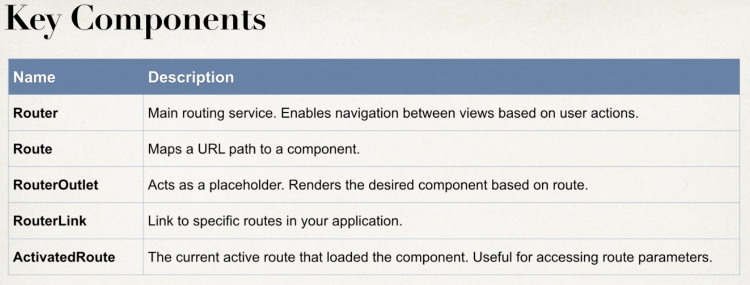

Development Process

1. Define routes
   1. App.module.ts: define routes
   2. Specfic -> generic -> 404
2. Configure Router based on our routes
   1. @NgModule -> imports -> RouterModule.forRoot(routes)
3. Define the Router Outlet
   1. App.component.html
4. Set up Router Links to pass category id param
   1. App.component.html -> Menu sidebar -> href replace with routerLink
5. Enhance ProductListComponent to read category id param
   1. product-list.component.ts: add currentCategoryId: number = 1
   2. Constructor -> Inject the ActivatedRoute
   3. ngOnInit() this.route.paramMap.subscribe()…
6. Modify SpringBoot app – REST Repository needs new method
   1. ProductRepository add method
7. Update Angular Service to call new URL on Spring Boot app
   1. Product.service.ts -> getProductList()

13 Search for products by category (dynamic)

Development Process

1. Modify Spring Boot app – Expose entity ids
   1. MyDataRestConfig: add EntityManager
   2. Get a list of all entity classes from the entity manager
   3. Create an array of the entity types
   4. Get the entity types for the entities
   5. Expose the entity ids for the array of entity / domain types
2. Create a class: ProductCategory
   1. ng generate class common/product-category
3. Create new component for menu
   1. ng generate component components/product-category-menu
      1. product-category-menu.ts
4. Enhance menu component to read data from product service  
   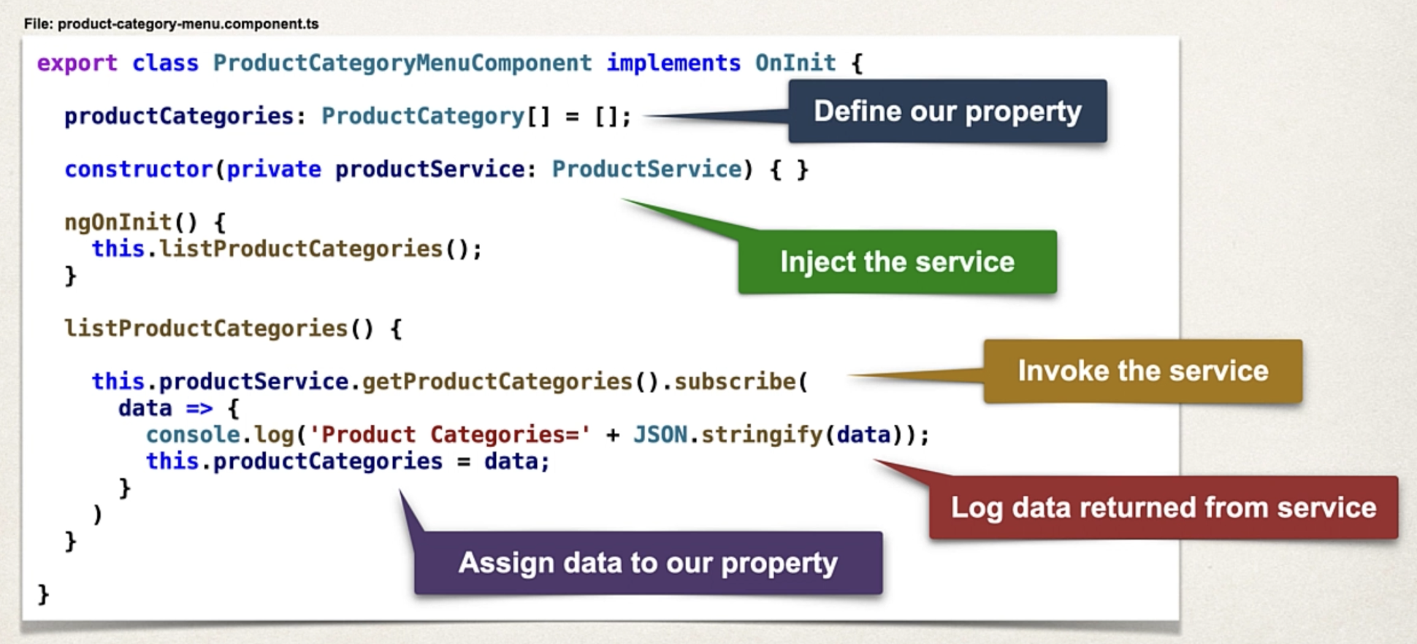
5. Update product service to call URL on Spring Boot app
   1. Product.service.ts
6. In HTML, replace hard-coded links with menu component
   1. App.component.html: update hard-coded links; copy selector from product-category-menu.component.ts
   2. Product-category-menu.component.html

14 Search by keyword

1. Modify Spring Boot app – Add a new search method
   1. Dao -> ProductRepository
2. Create new component for search
   1. ng generate component components/search
3. Add new Angular route for searching
   1. App.module.ts
4. Update SearchComponent to send data to search route
   1. App.component.html copy and paste to search.component.html
   2. Supporting code for search button: search.component.ts
5. Enhance ProductListComponent to search for products with ProductService
   1. Product-list.component.ts: add handleListProducts()
   2. What about product not found? Display a message.
      1. Product-list-grid.component.html
6. Update ProductService to call URL on SpringBoot app
   1. Product-service.ts: create method: searchProducts()
   2. Refactor: make the code concise and reusable

15 Master Detail view

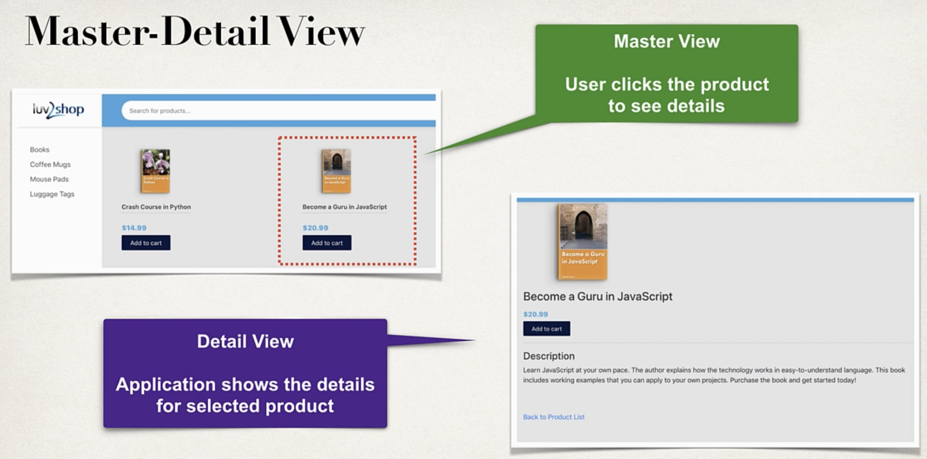

Development process

1. Create new component for product details
   1. Ng generate component components/ProductDetails
2. Add new Angular route for product details  
   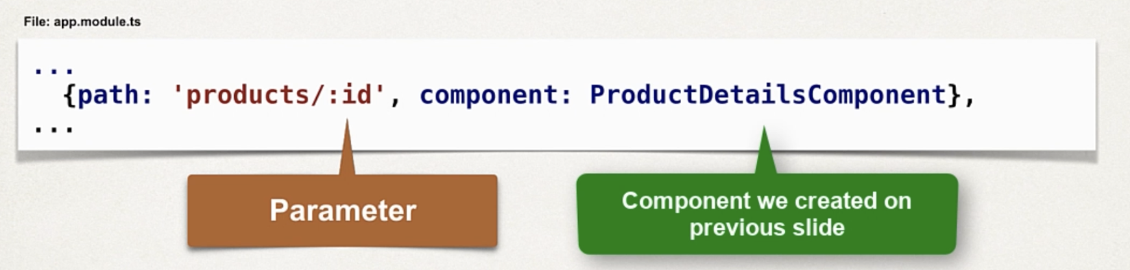
3. Add router links to the product-list-grid HTML page
4. Enhance ProductDetailsComponent to retrieve products from ProductService
5. Update PorductService to call URL on Spring Boot app  
   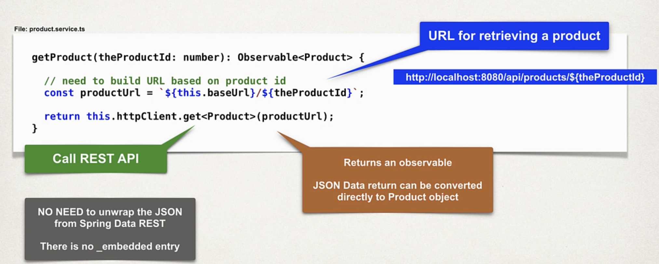
6. Update HTML page for ProductDetailsComponent to display product details  
   